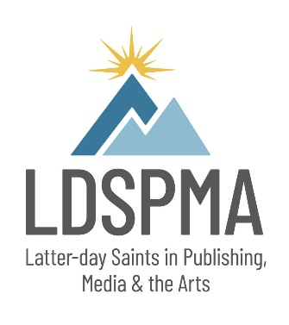

LDSPMA Fast Pitch
Worksheet

Book Title: Genre:
Intended Audience:

List of books similar to yours (minimum of three):

How is your book different from others?

Write a 2–3 paragraph synopsis of your book:

Marketing Plan
List your social media platforms and number of followers on each platform:

Links to blog or website:

Describe your branding as an author for this book:

Since most publishers require authors to help market their books, please explain your marketing plan in as much detail as possible:

